Name: Anuj Singh
Roll no: 23/38033
Sem: 5th
(DSE: Data Privacy)

1. Write a program to perform encryption and decryption using Caesar cipher
(substitutional cipher).
import string

def encrypt(text, shift):
result=""
for i in range(len(text)):
char=text[i]
if(char.isupper()):
result+=chr((ord(char)-ord('A')+shift)%26+ord('A'))
elif char.islower():
result+=chr((ord(char)-ord('a')+shift)%26+ord('a'))
else:
result+=char

return result

def decrypt(text, shift):
return encrypt(text, -shift)

def main():
text="bbb"
shift=2
cipher_text=encrypt(text, shift)
print(f"Encrypted text:{cipher_text}")
plain_text=decrypt(cipher_text, shift)
print(f"After decryption: {plain_text}")
main()

Output:
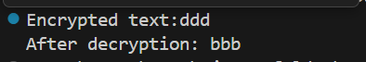

2. Write a program to perform encryption and decryption using Rail Fence Cipher
(transpositional cipher)
def encrypt_rail_fence(text, key):
if key<2:
return text

rail=[['\n' for i in range(len(text))] for j in range(key)]

dir=False
row, col=0, 0
for i in text:
rail[row][col]=i
col+=1

if row==0 or row==key-1:
dir=not dir

if dir:
row+=1
else:
row-=1

result=[]
for i in range(key):
for j in range(len(text)):
if(rail[i][j]!='\n'):
result.append(rail[i][j])
return "".join(result)

def decrypt(cipher, key):
if key<2:
return cipher
rail = [['\n' for i in range(len(cipher))] for j in range(key)]

dir_down = None
row, col = 0, 0

for i in range(len(cipher)):
if row == 0:
dir_down = True
if row == key - 1:
dir_down = False

rail[row][col] = '*'
col += 1

if dir_down:
row += 1
else:
row -= 1

index = 0
for i in range(key):
for j in range(len(cipher)):
if rail[i][j] == '*' and index < len(cipher):
rail[i][j] = cipher[index]
index += 1

result = []
row, col = 0, 0
for i in range(len(cipher)):
if row == 0:
dir_down = True
if row == key - 1:
dir_down = False

if rail[row][col] != '\n':
result.append(rail[row][col])
col += 1

if dir_down:
row += 1
else:
row -= 1

return "".join(result)

def main():
text="helloworld"
key=3
cipher_text=encrypt_rail_fence(text, key)
print(f"After encryption: {cipher_text}")
plain_text=decrypt(cipher_text, key)
print(f"After decryption: {plain_text}")

if __name__=="__main__":
main()

Output:
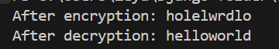

3. Write a Python program that defines a function and takes a password string as input and
returns its SHA-256 hashed representation as a hexadecimal string.
import hashlib

def sha256_hash(password):
encoded_password=password.encode()
hash_object=hashlib.sha256(encoded_password)
return hash_object.hexdigest()

def main():
password=input("Enter a password: ")
hashed_password=sha256_hash(password)
print("SHA-256 hashed password: ", hashed_password)
main()

Output:

4. Write a Python program that reads a file containing a list of usernames and passwords, one pair per line (separated by a comma). It checks each password to see if it has beenleaked in a data breach. You can use the "Have I Been Pwned" API (https://haveibeenpwned.com/API/v3) to check if a password has been leaked.
import hashlib
import requests

def check_password_pwned(password):
sha1_hash = hashlib.sha1(password.encode()).hexdigest().upper()

prefix = sha1_hash[:5]
suffix = sha1_hash[5:]

url = f"https://api.pwnedpasswords.com/range/{prefix}"
response = requests.get(url)

if response.status_code != 200:
raise RuntimeError("Error fetching data from HaveIBeenPwned API")

hash_list = response.text.split("\n")

for line in hash_list:
h, count = line.split(":")
if h == suffix:
return int(count)

return 0

filename = "Directory.txt"

print("Checking passwords against HaveIBeenPwned...")

try:
with open(filename, "r") as file:
for line in file:
line = line.strip()

if not line:
continue

try:
username, password = line.split(",")
except ValueError:
print(f"Invalid line format: {line}")
continue

count = check_password_pwned(password)

if count > 0:
print(f"[LEAKED] User '{username}' → Password found {count} times!")
else:
print(f"[SAFE] User '{username}' → Password not found in breaches.")

except FileNotFoundError:
print(f"Error: File '{filename}' not found.")

Output:
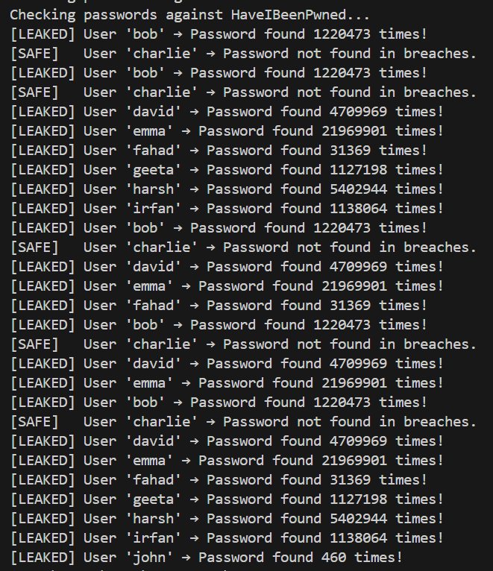

5. Write a Python program that generates a password using a random combination of
words from a dictionary file.
import random

def generate_password(filename, num_words=4):
try:
with open(filename, "r") as file:
words = [word.strip() for word in file.readlines() if word.strip()]

selected_words = random.sample(words, num_words)

password = "-".join(selected_words)

return password

except FileNotFoundError:
print("Error: Dictionary file not found.")
except ValueError:
print("Error: Not enough words in dictionary to generate password.")

dictionary_file = "passwords"
password = generate_password(dictionary_file, num_words=4)
if password:
print("Generated Password:", password)

Output:
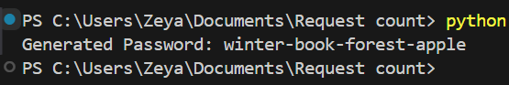

6. Write a Python program that simulates a brute-force attack on a password by trying out
all possible character combinations.
import itertools
import time

def brute_force_attack(target_password):
characters = "abcdefghijklmnopqrstuvwxyz"
attempt_count = 0
start_time = time.time()

for length in range(1, len(target_password) + 1):
for combo in itertools.product(characters, repeat=length):
attempt = "".join(combo)
attempt_count += 1

if attempt == target_password:
end_time = time.time()
print(f"Password found: {attempt}")
print(f"Total attempts: {attempt_count}")
print(f"Time taken: {end_time - start_time:.4f} seconds")
return

print("Password not found.")

password=input("Enter the password to brute force : ")
brute_force_attack(password)
Output:
